

LS210 Tapkar feeder User Manual
Powered by Libra Measuring Instruments

Contents
1. Introduction 3
2. Operating Instructions 4
2.1 Indicator Display 4
2.2 Keypad 5
3. Switching ON 5
4. Using the scale 6
4.1 Using the Tare Function 6
4.2 Totalising Function 7
4.3 Storing a Transaction 7
4.4 Manual Cart Loading/Offloading 9
5. Changing the scale Parameters 10
6. How to view Stored Information 13
7. Setting up the User Fields 14
8. User Codes 15
9. User Header 15
10. Diagnostics 16
11. Calibration mode 17
12. Weighbill 18
13. Keypad Use 19
14. Communication with a PC 19
15. Help 20

1. Introduction
The LMI vehicle weighing system consist of a weighing bin and an indicator (LMI LS210).
The indicator has several functions, with which the user can weigh and store product information, weight transactions and print weigh bills.
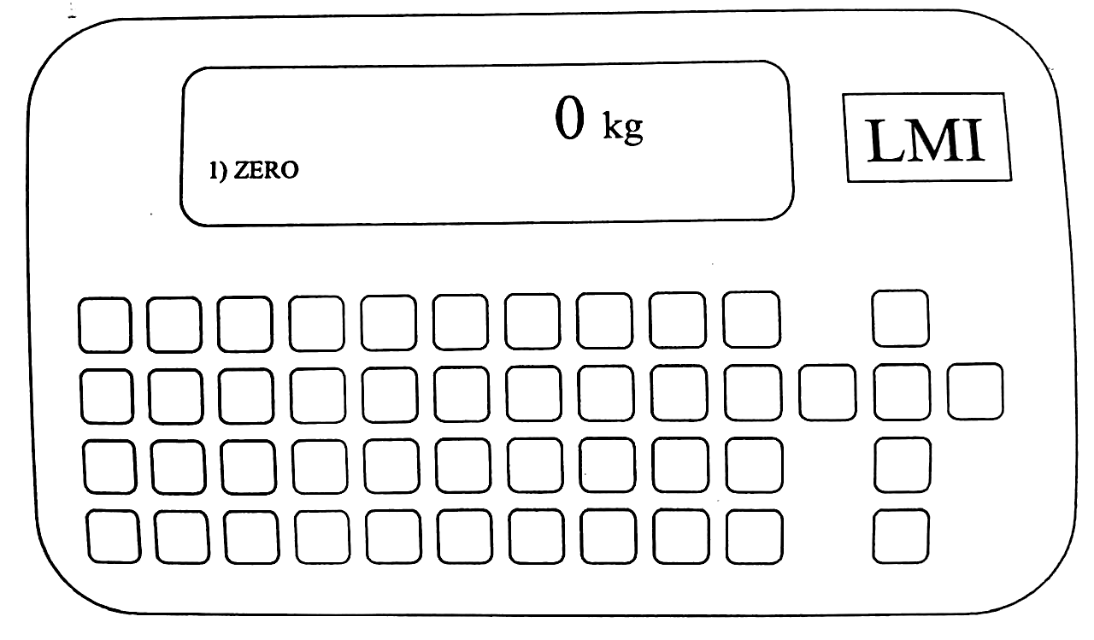
Fig 1. Basic layout of the LMI LS210 indicator
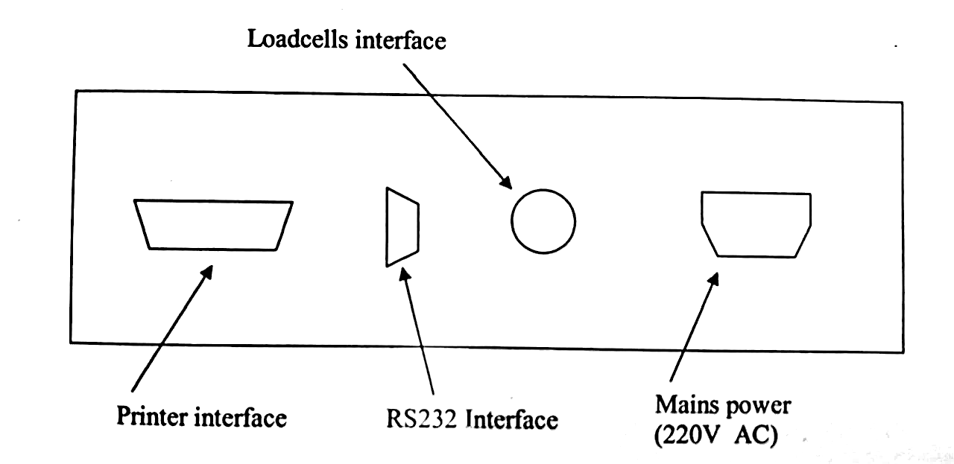
Fig 2. Connections on the LS210 Indicator

2. Operating Instructions

2.1 Indicator Display
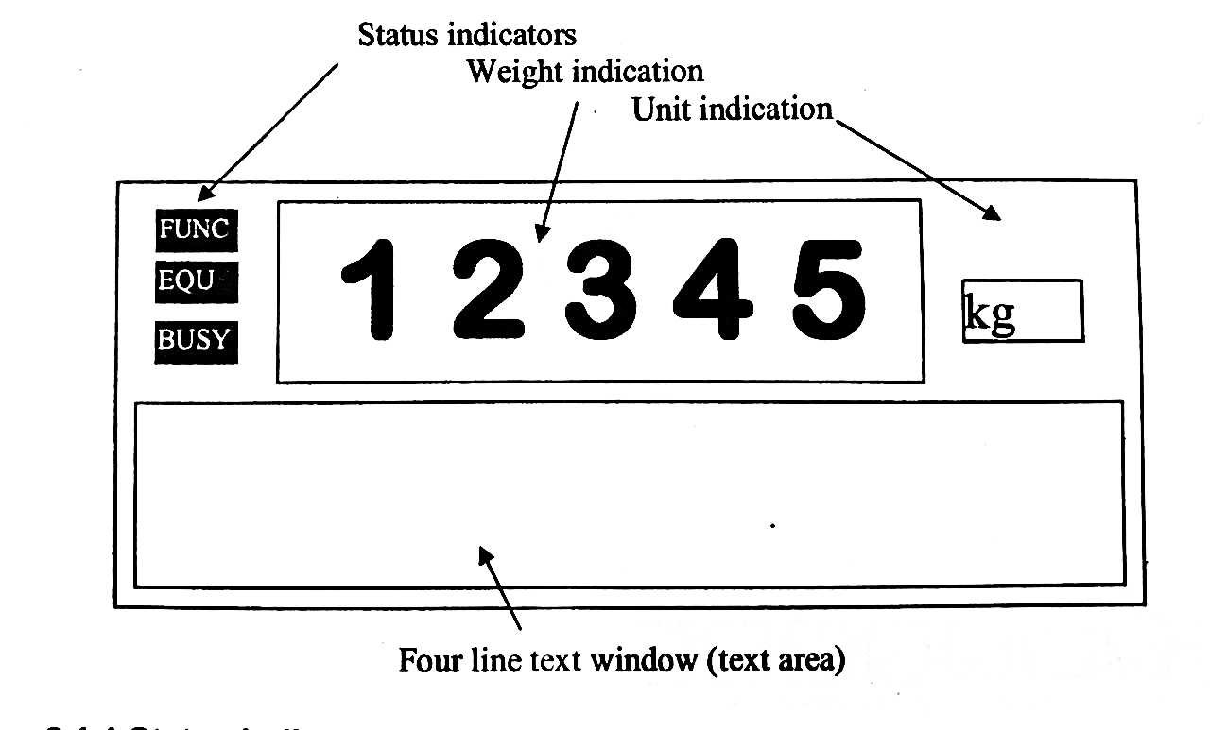

2.1.1 Status Indicators
There are three status indicators:
- FUNC = Indicates the function key has been pressed. Some keys (most of the keys on the upper row), have a double function. For instance, key [3] is also used to access the printer. In normal mode, key [3] is used to enter the 3 figure. Similarly, key [6] is also used for Recall, and so on.
- EQU = indicates that equilibrium was established and that functions such as zero or taking a reading, can be performed.
- BUSY = indicates that the scale is busy with internal functions.

2.1.2 Weight indication
The weight indicated is the weight currently on the scale. If more than the scale’s maximum weight capacity is present on the platform, an indication of ‘ -----’ will be given. The scale also shows negative weight: if something (a light vehicle, or people) are present on the scale (weighing, for instance, 500kg) and the instrument is zeroed with this load on the platform, by removing the load, the scale will show ‘-500kg’. However, if this load is higher than 2 000kg, an indication of ‘----’ will be given.

2.1.3 Unit Indication
Indicates the weight unit.

2.1.4 Text window
The 4-line text window is used to display information to the user.

2.2 Keypad
There are three main uses of the keypad:
- Alphanumeric keys: for typing information asked for by the indicator unit.
- Arrow Keys: For selecting options and moving the cursor.
- Function Keys: For selecting menus and for data manipulation. To use the special functions, press the [FUNC] key,(the FUNC status indicator will now be displayed) and then press the desired special function key.
- [FUNC] + [Weigh/1] exits any sub menu and starts the weighing operation.

3. Switching ON
When switching on the indicator, the display will show the scale model, then it will recall the stored data. The indicator will then display in sequence “Starting up”, “Recall data”, “Checking loadcells” and “Ready”. The software version number will also automatically be displayed in the bottom corner of the display. The scale will then automatically zero. If there is any weight of more than approximately 1 000kg on the platform, it will not zero.
After a minimum warm-up period of 10 minutes the scale is ready to be used.

On Startup the display will show the following:
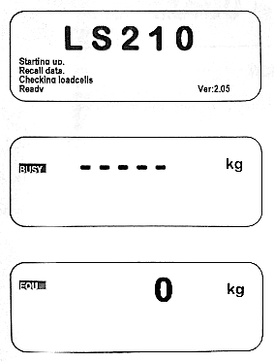

4. Using the scale
There are a few ways of using the scale to determine throughput or individual loads.

4.1 Using the Tare Function
There is a TARE function built into the scale. By pressing [ZERO] the scale will tare the current value and display 0kg on the main display, with ‘TAP IN’ or ‘TAP UIT’ below the weight.
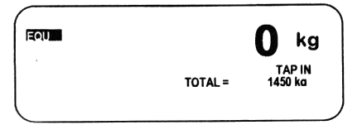
If you want to see the gross mass inside the bin, press [FUNC] + [z] and the main display will show the gross mass. The ‘TAP IN’ or ‘TAP UIT’ will disappear.
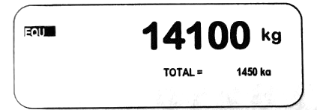

4.2 Totalising Function
We suggest this function is only used with the tare function active, i.e., only use the addition when the ‘TAP IN’ or ‘TAP UIT’ message is displayed.
NOTE: the total mass value can only be cleared by switching the scale off and back on again.
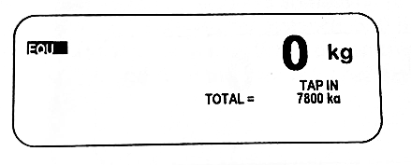
Whether the scale is empty or not, press the [ZERO] button, the scale will display ‘0kgs’, ‘Total = 0kg’ and ‘TAP IN’. Now start filling the bin with the first load. Once the first load is completed press [ENTER] and [ZERO] again. EG, let’s say there is 1 500kg currently in the bin after startup. The load being delivered is 7 800kg, the display will now show:

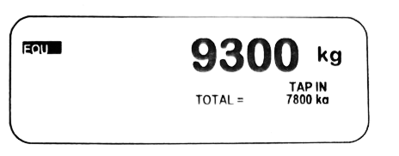
If you press [FUNC] +[Z] the display will change to:

The main weight will display the gross in the bin and the total added in this session. Continue to add loads and add their value by pressing [ENTER] + [ZERO] after each load.

4.3 Storing a Transaction
With a total of zero, start by entering the truck number/registration number.
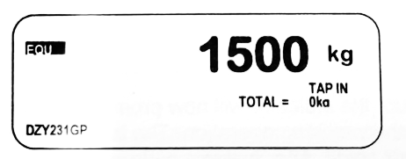
Press the [I.D.] Key.
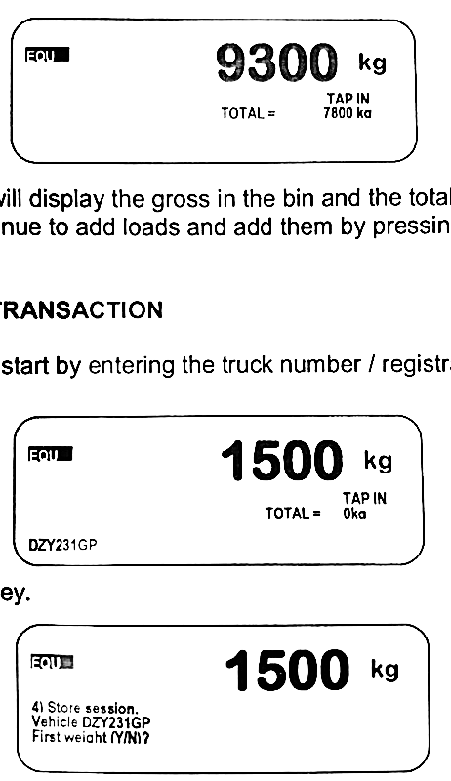
Press the [Y] key and the indicator will proceed in storing the data and clearing the screen. The first mass is now stored in the indicator as 0kg.
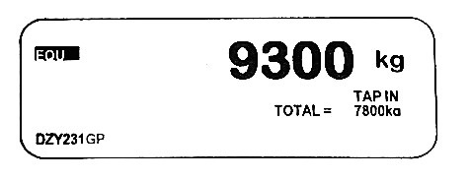
Now start loading product into the bin. Once all the loads for a specific transaction is added (this can be only one load as well) the weight can be stored in memory. Start by typing in the truck number or registration number. The display will show (we use the example above):

Press the [I.D.] key. If the EQU status indicator does not show, the indicator will respond with: “Waiting for stable reading”.
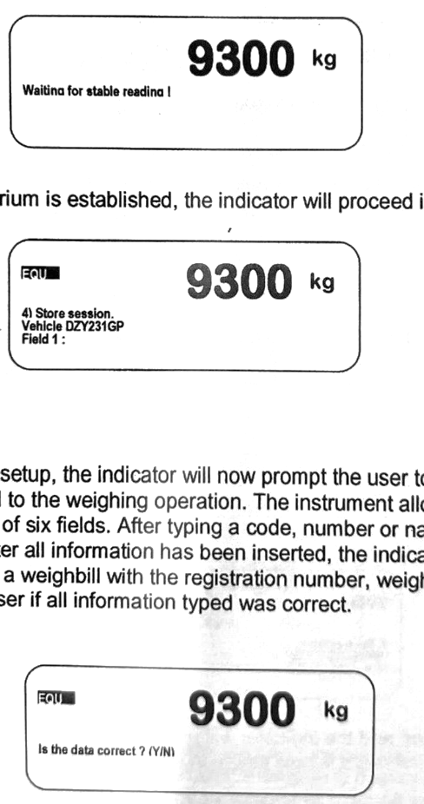
As soon as equilibrium is established, the indicator will proceed in storing the weight.
Depending on the setup, the indicator will now prompt the user to enter information related to the weighing operation. The instrument allows for a maximum number of six fields. After typing a code, number or name press the [ENTER] key. After all information fields have been completed, the indicator will automatically print a Weighbill with the registration number, weights, date, etc. It will then ask the user if all entered information was correct.
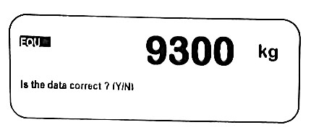
If the information on the Weighbill is incorrect, press the [N] key and the indicator will prompt for all the fields again. If the Weighbill is correct, press the [Y] key. All the information as printed on the Weighbill will be stored and the display will be cleared. This information can be printed again as a Weighbill or can be downloaded to a computer for further processing.

4.4 Manual Cart Loading/Offloading
IMPORTANT: When either option is started, you must press Enter after loading or offloading to save the weight.

4.4.1 Truck Offloading
Use this option when offloading product from the cart to the truck.
- Under the ID menu, select Option 1 – “Start Truck Loading” to begin.
- Press Enter to record and add each offload amount to the total offloaded weight.
- When offloading is complete, press Option 1 again – “Stop Truck Loading”.
- Enter the prompted information.
- Once all data is entered, the scale will automatically save the entry.

4.4.2 Cart Loading/Throughput
Use this when calculating the total weight added to the cart(s) during loading.
- Under the ID menu, select Option 2 – “Total Throughput”.
- Press Option 2 again – “Busy Totalling” once you are done loading the cart(s).
- Enter the prompted information.
- After completion, the data will be saved automatically.

4.4.3 Status Indicators
Not Loading: The "Start Truck Loading" process has not been initiated yet.
Loaded: Displays the total amount offloaded from the cart to the truck.
Fill Cart: Only when Option 1 has started, and weight is being loaded into the cart, will this status show.

5. Changing the scale Parameters
Note: most of the functions that are changeable with SETUP are set by the manufacturer and should not be changed if not absolutely necessary.
Press the [FUNC] key and then the [Setup/9] key. To scroll through the various options, use the up and down arrow keys. And to cycle through an options settings, press [ENTER].
- Increments (e): Sets the smallest indication and can be changed from 1kg to 50kg. This setting is only active in calibration mode.
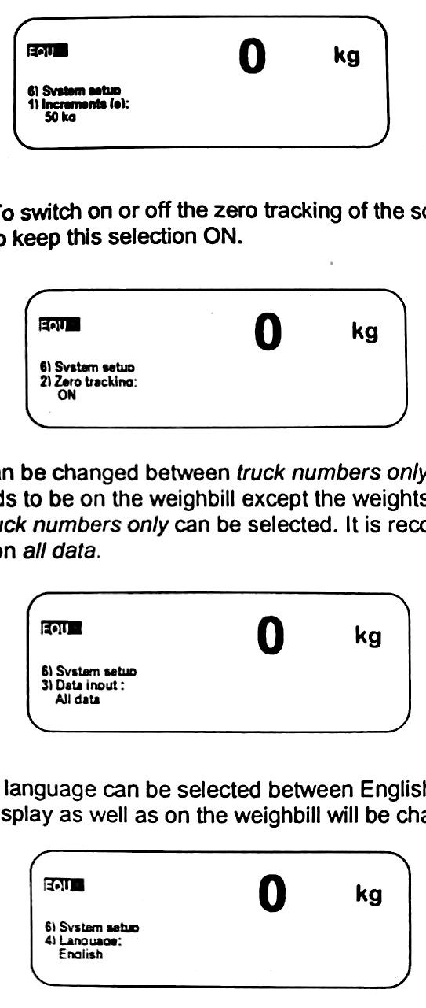
- Zero Tracking: To switch on or off the zero tracking of the scale. We recommend keeping it ON.
- Data input: It can be changed between truck numbers only and all data. If no information needs to be on the Weighbill except the weights and vehicle number, then truck numbers only can be selected. The recommended option is all data.
- Language: The language can be selected between English and Afrikaans. All text on the display as well as on the Weighbill will be changed accordingly.
- Measuring Mode: There is a stabilizing filter in the indicator, and it can be selected if the measuring mode is set to FILTER. With the setting set to NORMAL, no filter is present.
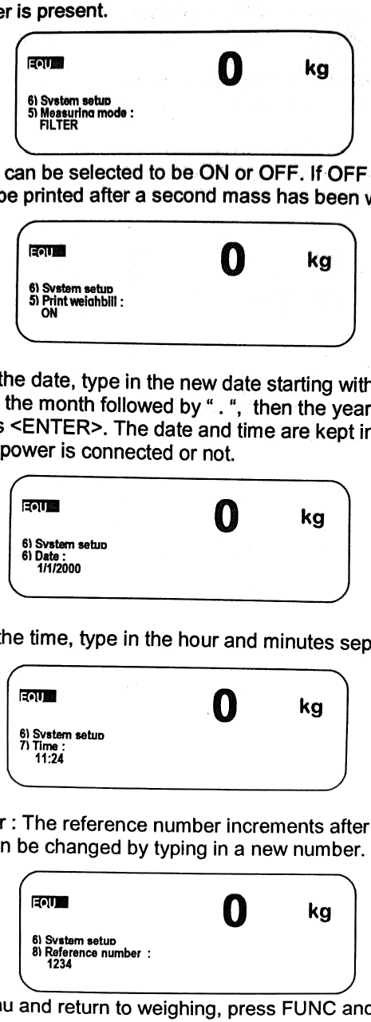
- Print Weighbill: It can be turned ON or OFF. If OFF is selected, a Weighbill will not be printed after a second mass has been weighed.
- Date: To change the date, type in the new date starting with the day, then the [.] ‘dot’ key, then the month followed by [.], then the year as a four-digit number and press [ENTER]. The date and time are kept in memory irrespective if the power is connected or not.
- Time: To change the time, type in the hour and minutes separated by the [.] key as done for the date.
- Reference Number: The reference number increments after each weighing session, and it can be changed by typing a new number the pressing [ENTER] to save.
To exit Setup and return to weighing, press [FUNC] + [WEIGH/1]

6. How to view Stored Information
By pressing [FUNC] + [RECALL/6], stored information of previously weighed vehicles can be viewed.
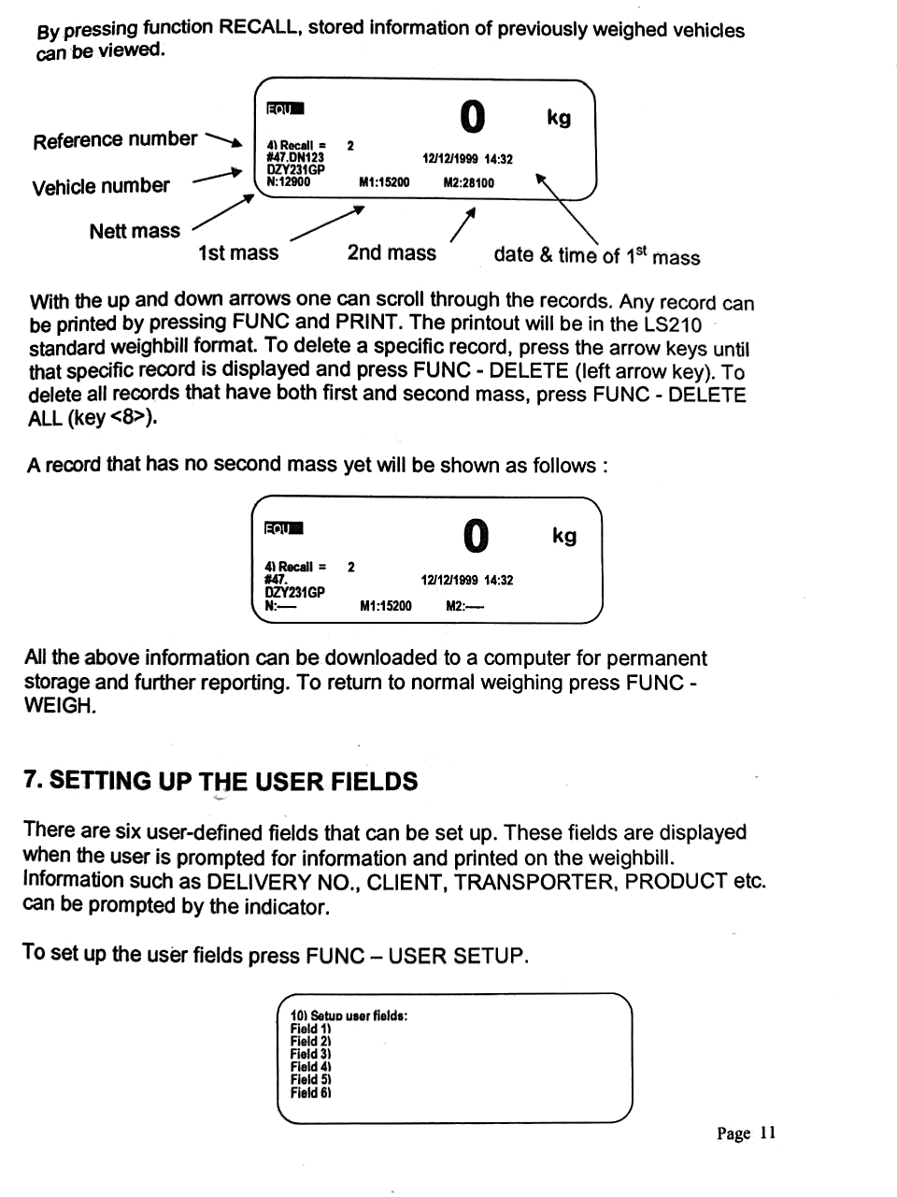
With the up and down arrows, one can scroll through the records. Any record can be printed by pressing [FUNC] + [PRINT/3]. The printout will be in the LS210 standard Weighbill format. To delete a specific record, press the arrow keys until that specific record is displayed and press [FUNC] + [DELETE/<]. To delete all records that have both first and second mass, press [FUNC] + [DELETE ALL/8].
A record that has no second mass yet will be shown as follows:
All the above information can be downloaded to a computer for permanent storage and further reporting. To return to normal weighing press [FUNC] + [WEIGH/1].

7. Setting up the User Fields
There are six user-defined fields that can be set up. These fields are displayed when the user is prompted for information and printed on the Weighbill. Information such as DELIVERY NO., CLIENT, TRANSPORTER, PRODUCT, etc. can be prompted by the indicator.
To set up the user fields press [FUNC] + [USER FIELDS/7]:
A Cursor indicates which of the six fields will be edited. The cursor can be moved up or down by pressing the up and down arrow keys. For example, change field 2 to CLIENT. Move the curser down until it blinks next to field 2 and start typing [C] [L] [I] [E] [N] [T] and then press [ENTER]. If not, all fields are to be used, type [.]’dot’ next to the field and press[ENTER]. This will disable the field.
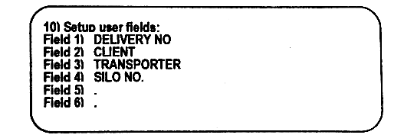
In this example, when weighing the same truck for the second time (first time loaded and second time empty, or vice versa) the user will be asked for a delivery number, client, transporter and silo number. The last two fields will not be displayed.
As inputs to the user fields one can use user codes. Each user code has user information connected which will be printed on the Weighbill. This simplifies the number of keys to be pressed when typing the data. See USER CODE for more information. To print the user codes with the stored information press [FUNC] + [PRINT/3].

8. User Codes
User codes can be downloaded from a PC for easier entry of information and more detailed weigh bills. To print the user codes and associated information, enter the user fields menu and press [FUNC] + [PRINT/3].
A user code can be any alphanumeric string of 9 characters maximum length. The associated data can be of any length. The user code must ensure that the data can fit on the Weighbill. E.G. a user code such as C01 can have associated information of: A van der Merwe, P.O. BOX 31, Pretoria, 0186.
In this instance, by typing only three keys the customers name as well as the address can be displayed on the Weighbill.
These user codes must be set up on a computer and downloaded via a RS232 cable onto the LS210.

9. User Header
It changes the header on top of the Weighbill. To activate it, press [FUNC] + [USER HEADER/5].
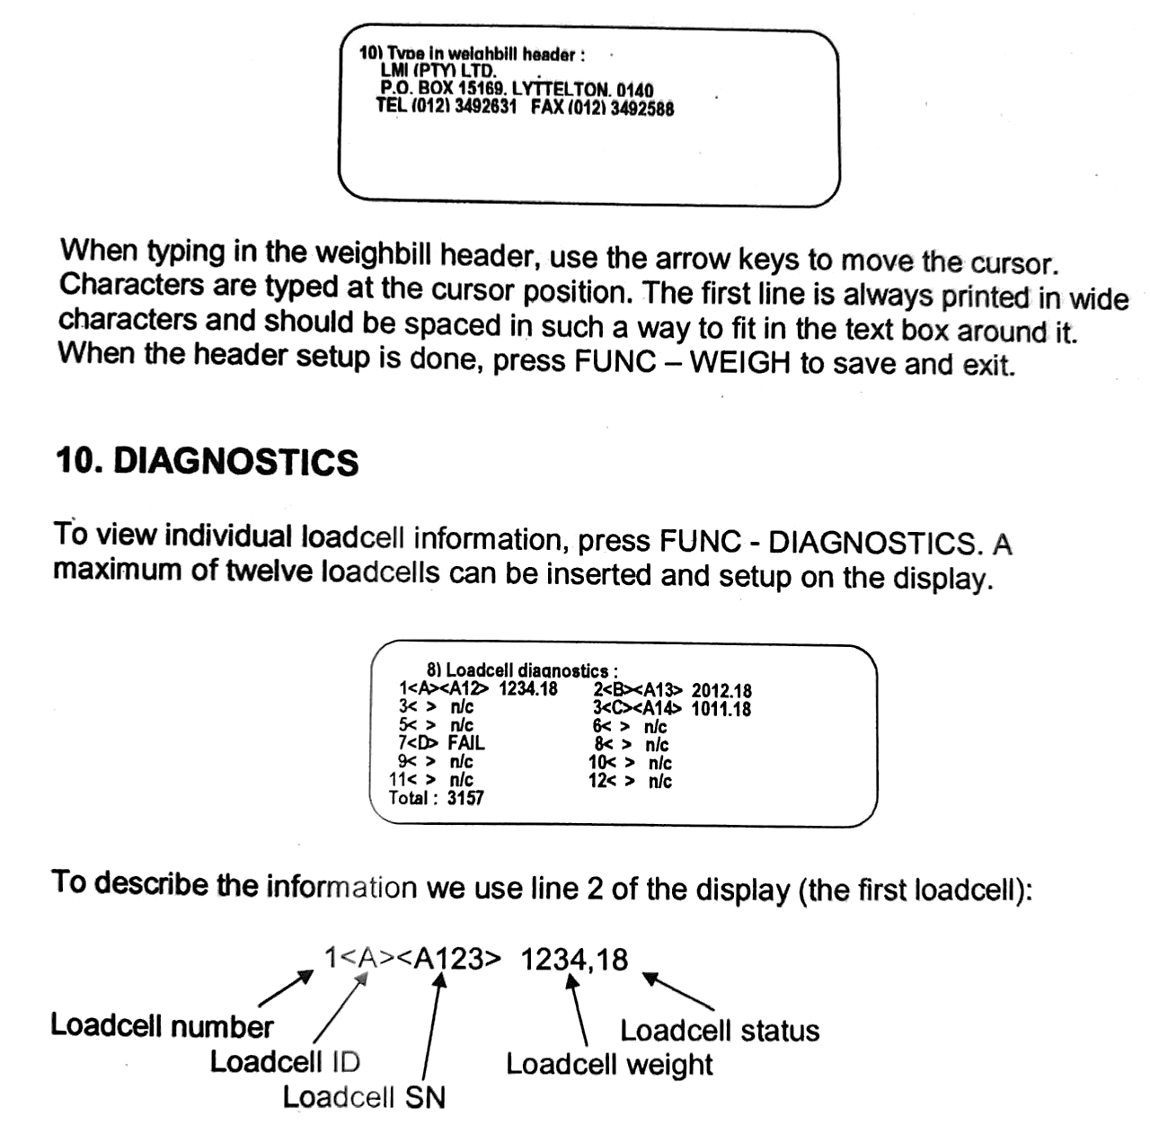
When typing in the Weighbill header, use the arrow keys to move the cursor. Characters are typed at the cursor position. The first line is always printed in wide characters and should be spaced in such a way to fit in the text box around it. When the header setup is done, press [FUNC] + [WEIGH/1] to save and exit.

10. Diagnostics
To view individual loadcell information, press [FUNC] + [DIAG/4]. A maximum of twelve loadcells can be inserted and setup on the display.
To describe the information, we use line 2 of the display (the first loadcell):
For each loadcell (1 to 12) the following information is displayed:
- Loadcell number = loadcell number
- Loadcell ID = Factory-set loadcell ID. For communication, all ID’s must be different. Range from A to Z.
- Loadcell SN = Loadcell serial number. Each loadcell is electronically marked with a unique serial number. The serial number is three alphanumeric digits.
- Loadcell Weight = The weight measured by each individual loadcell can be viewed.
- Loadcell Status = The loadcell status must be 18 for the weighbridge to function correctly.
The changing of any information is only active in calibration mode. To setup a loadcell, move the cursor down or across to an open position and type the loadcell ID. The indicator will then automatically read the serial number and weight. If the loadcell is not properly connected or the ID is incorrect, the display will show FAIL. To delete a loadcell from the list, move the cursor to the unwanted loadcell ID and press the [.] key, the ID will be deleted. To zero all loadcell weights press [ZERO].
To exit, press [FUNC] + [WEIGH/1]. The indicator will then save all loadcell information in its memory. The information cannot be changed except in calibration mode.

11. Calibration mode
To enter calibration mode, the DIP switch marked “Calibration Mode” must be switched to the ON position. When switching the indicator on, after the initial start-up the weight will be indicated, as well as the calibration value.

To change the value, use the up and down arrow keys. To change the value faster, use the left and right arrow keys. The value range is 0.5 up to 1.5. To store press [FUNC] + [WEIGH/1].

12. Weighbill
A typical weighbill will look as follows
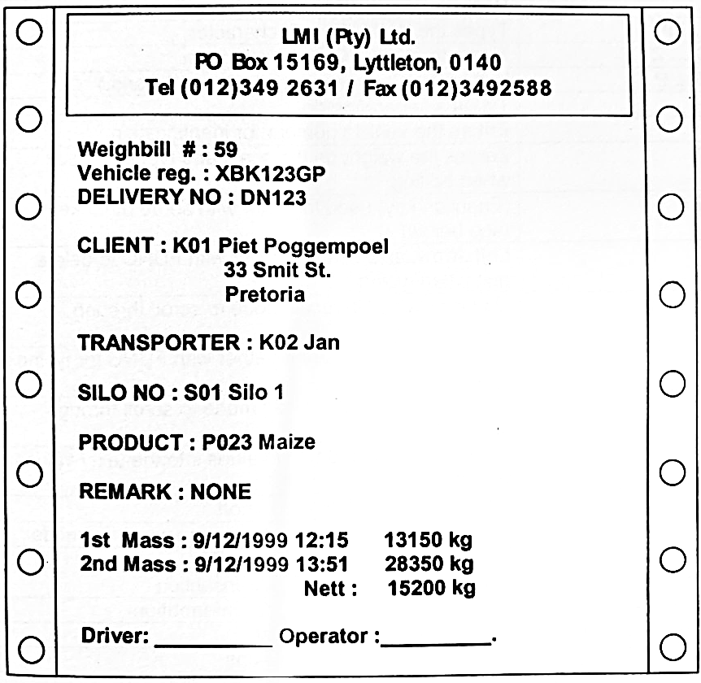

13. Keypad Use
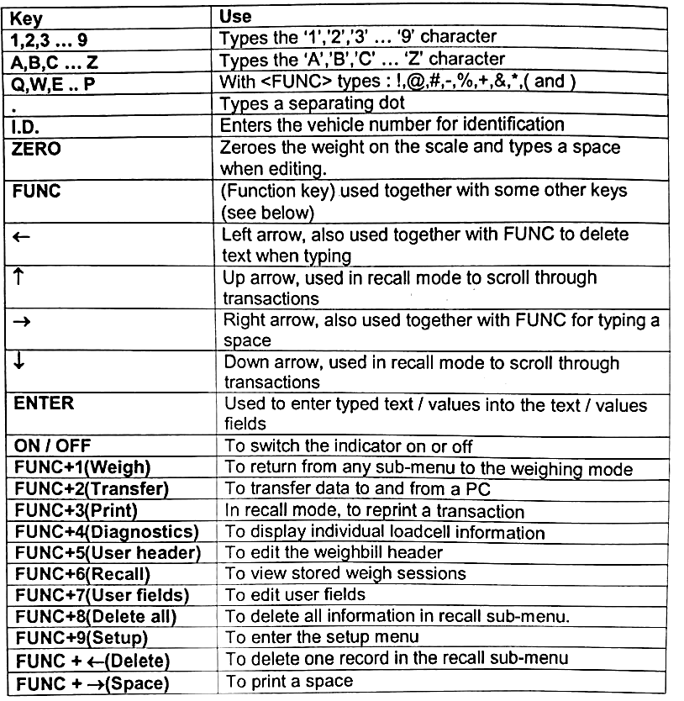

14. Communication with a PC
Connect the supplied RS232 cable from the PC to the LMI LS210 unit. Run the supplied software on the PC. Then press the [FUNC] + [TRANSF/2] keys. The indicator will then ask whether data needs to be uploaded (from the PC to the instrument) or downloaded (from the instrument to the PC). For more details, refer to the instructions for the PC software.

15. Help
If you need any further assistance or information, feel free to contact us at the applicable branch office and we will get you in touch with our software support team.
LMI Pretoria: 012 803 2805
LMI Bredasdorp W/Cape: 028 425 1463

Or if you’d prefer; Scan the QR Code below and head over to our YouTube channel or our website to watch this manual in video format, accompanied with visual demonstrations.
YouTube Channel:  LMI Scales | Website:  www.lmi.co.za
 | 

