

LS4s Silo Scale

User Manual

Powered by Libra Measuring Instruments
Contents
1. Description 3
2. Electronic Instrument LS4S 3
3. Setup 4
4. Scale Operation 6
4.1 Normal Operation 6
4.2 Zero Calibration of Scale 6
5. Technical Information 7
6. Your LMI Warranty 7
7. Help 8

1. Description
The LMI electronic silo scale consists of:
- An electronic indicator /instrument,
- a 12V, 500mA, 9W AC/DC adaptor
- User manual.
The LS4S (Silo) instrument utilizes loadcells placed on strategic points around a silo to capture the mass of the contents of the respective container.
The instrument can store weight, as to be able to tare the mass of the silo or container upon installation. This enables the instrument to have a zero reading with the silo installed on the loadcells and an empty bin.
From here the silo can be filled, and the mass will display on the instrument accordingly.

2. Electronic Instrument LS4S
This electronic instrument has a variety of features. The keyboard has the following keys:
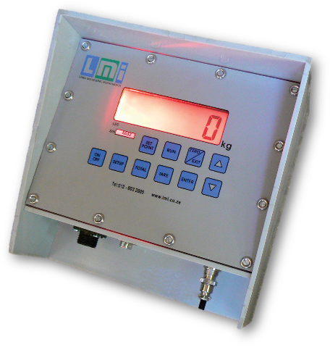
- ON /OFF
- SET POINT
- RUN
- ZERO /EXIT
- TOTAL
- TARE
- ENTER
- UP- and DOWN ARROWS
- SETUP

The ON /OFF key is used to switch the instrument on, or off.

The SET POINT key is used to take the instrument into download mode. When pressing this button the display will show “dAt”. You can now hold the download button into the download receptacle. The data will be downloaded onto the button for transfer to the PC. The screen will display the percentage downloaded during the process. If the function did not complete successfully, it will display “-F-“ otherwise “donE”. Press ENTER to return to weighing mode.
The RUN key is not operational in this model of scale.
The ZERO /EXIT key is used to zero the scale whenever necessary. (EXIT function not operational in this model of scale).
The TOTAL key is used for memory usage. Press ENTER to erase all data stored (to be done after downloading).
The TARE key is used to take the display back to displaying the gross weight in the silo.
The ENTER key is used to store the current mass data under the TOTAL key setting.

3. Setup
The SETUP key is used for several different options or checks:
- Backlight (on /off).
- Sample time (1-59 minutes).
- Speed measuring mode (standard /high /low).
- Charging voltage check.
- Battery voltage check.
- Date settings (Day).
- Date settings (Month).
- Date settings (Year).
- Time settings (Hours).
- Time settings (Minutes).
- Scale number.
- Sample weight.
- Remote display.-
Press SETUP and then scroll with the UP and DOWN buttons until the desired setting appears on the screen. To setup the backlight, scroll until “1” appears on the left side of the screen. Press the ENTER key to change from backlight on to backlight off, or vice versa.
Press the UP key to go to the next setup. If the UP key is pressed, the display shows: “2” (sample time) and then 1 – 59 minutes, or AUTO. As before, press the ENTER key to change the sample time. This sample time, represented in minutes, is the time between weight storage for downloading to the PC software. AUTO setting is for store only on change of weight and not periodically.
Pressing the UP key again goes to the next setup “3” (speed measuring mode). This mode depends on the type of weighing that one is performing. For static loads (bags of grain, feed etc.) use “Std” (Standard). When weighing animals on a simple platform, where the animal is likely to touch walls, fences, etc., use “Hi” (High speed). When weighing animals in a crate (animal completely isolated from the surroundings) use “Lo” (Low speed).
NB: DO NOT USE “Loc” (Lock).
Setting “4” is used while charging the battery, with instruments equipped with internal battery. A minimum of 10V is advised when charging.
Setting “5” is used when not charging battery, with instruments equipped with internal battery. It should never go below 5.6V or above 6.9V. Optimal value is 6.8V, indicating the battery is fully charged.
Setting “6” is the “DAY” date setting. Press ENTER to change.
Setting “7” is the “MONTH” date setting. Press ENTER to change.
Setting “8” is the “YEAR” date setting. Press ENTER to change.
Setting “9” is the “HOURS” time setting. Press ENTER to change.
Setting “0” is the “MINUTES” time setting. Press ENTER to change.
Setting “A” is the scale number. Set the scale number if more than one silo is used on the same software.
Setting “t” is the sample weight setting. Sets the minimum weight change when scale is running on AUTO store.
Setting “r” is the remote display setting. Press ENTER to change. If the remote display is turned on, the respective instrument works as a remote display, meaning a second external silo instrument connects to this instrument, and the external silo instrument’s mass will display on this remote display. (Works like a repeater).
The instrument contains a rechargeable 6.4V Lead acid battery (approximately 12 hours of continuous use – 6 hours of charge to full. The closest 9-pin connector is used to connect to a PC with the software, while the furthest 9-pin connector is used to connect to an external display if remote display is required.

4. Scale Operation

4.1 Normal Operation
- Insert the plug of the cable coming from the loadcells into the readout instrument. The scale is now ready for the weighing operation. It is advisable to switch on the indicator some time before starting. (5 minutes will be sufficient).
- Press the “ON-OFF” button to activate the instrument. The display will show: “LS4” and successively display the current weight.
- If it is desired to check loads being loaded or offloaded, press the “ZERO” key to zero the display and observe the weight. Press the “TARE” key to revert back to the gross display. The unit will continue to sample the weight.

4.2 Zero Calibration of Scale
Press and hold the “ENTER” key, while pressing the “ON/ OFF” key. The first user selection is the scale increments. Press “ENTER” to select the respective scale increments. Then the scale display will show an amount. Press the “ZERO” key. To store the zero calibration, press the “ENTER” key, on the display it should show “Store”. You can now switch off the scale and turn it back on. It will be zero now.

5. Technical Information
The Baud rate used on the LS4 Silo instrument is 9600 regardless of which serial port is used.
The continuous output format for the string is as follows:
#1,0,0,*
#1,0,0,*
#1,0,0,*
#1,0,0,@1,0,2010/1/1,0:0,0,-2*

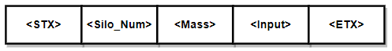

6. Your LMI Warranty
This scale is covered by a 12 month warranty from the date of purchase. The warranty covers every part of the scale against defects, for the period of 12 months.
If there are any faults, parts will be replaced and the defects repaired, free of charge, during this period.
The warranty does not cover misuse, negligent or incorrect handling of the product and does not cover damage due to lightning.
Kindly retain your tax invoice, as proof of purchase must be given if a claim is made under the present warranty terms.

Date of purchase: …..…..…..…..…..…..

7. Help
If you need any further assistance or information, feel free to contact us at the applicable branch office and we will get you in touch with our software support team.
LMI Pretoria: 012 803 2805
LMI Bredasdorp W/Cape: 028 425 1463

Or if you’d prefer; Scan the QR Code below and head over to our YouTube channel or our website to watch this manual in video format, accompanied with visual demonstrations.
YouTube Channel:  LMI Scales | Website:  www.lmi.co.za
 | 

